**DAILY ONLINE ACTIVITIES SUMMARY**

|  |  |  |  |  |  |  |  |
| --- | --- | --- | --- | --- | --- | --- | --- |
| **Date:** | **17/06/2020** | | | | **Name:** | **Sinchana K N** | |
| **Sem & Sec** | **IV sem & B section** | | | | **USN:** | **4AL18CS083** | |
| **Online Test Summary** | | | | | | | |
| **Subject** | | **-** | | | | | |
| **Max. Marks** | | **30** | | **Score** | | **-** | |
| **Certification Course Summary** | | | | | | | |
| **Course** | **Introduction to Information Security** | | | | | | |
| **Certificate Provider** | | | **Greatlearning academy** | **Duration** | | | **5.5 hours** |
| **Coding Challenges** | | | | | | | |
| **Problem Statement1:** Write a C Program to Count numbers that don’t contain 3. | | | | | | | |
| **Status: Executed** | | | | | | | |
| **Uploaded the report in Github** | | | | **YES** | | | |
| **If yes Repository name** | | | | **https://github.com/acchu1234sinchana/Lockdown_coding1** | | | |
| **Uploaded the report in slack** | | | | **YES** | | | |

Online Test Summary: No internals conducted today.

Online Certification Course Summary: Today I have learnt about Introduction to Software Security and also learnt how to prevent SQL injection and also about client state manipulation.

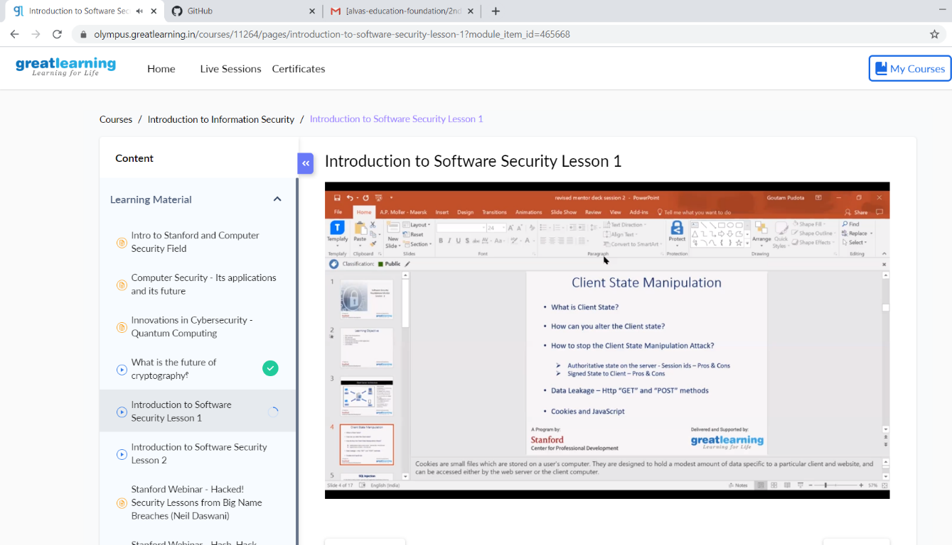

This is the Snap Shot of today’s session.

Online Coding Summary: **Today I had received one program from prof. Shilpa CSE Dept.The program is mentioned above in the coding challenges(pg.01). I have also uploaded it to my Github repository.**

